AI LAB OBSERVATION
Rhema Daphne (192321097)

EXPERIMENT 1: 8-Puzzle Problem
AIM
To develop a Python program that solves the 8-Puzzle Problem using Breadth-First Search (BFS) to find the shortest sequence of moves from the initial state to the goal state.
ALGORITHM
- Represent the puzzle as a 3×3 matrix.
- Define the goal state.
- Locate the empty tile (0).
- Generate all possible moves: up, down, left and right.
- Use Breadth-First Search (BFS) to explore possible states.
- Keep track of visited states.
- If the goal state is reached, display the solution path.
- If all possibilities are exhausted, report that no solution exists.
PROGRAM
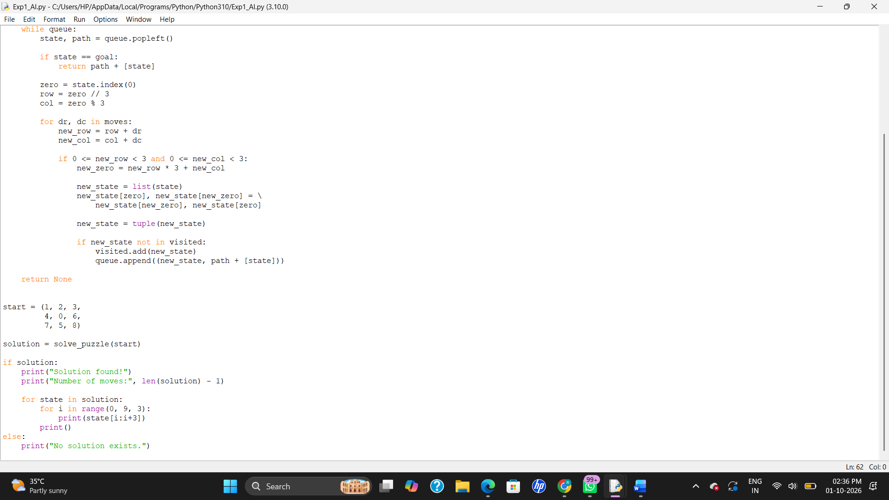

Output:
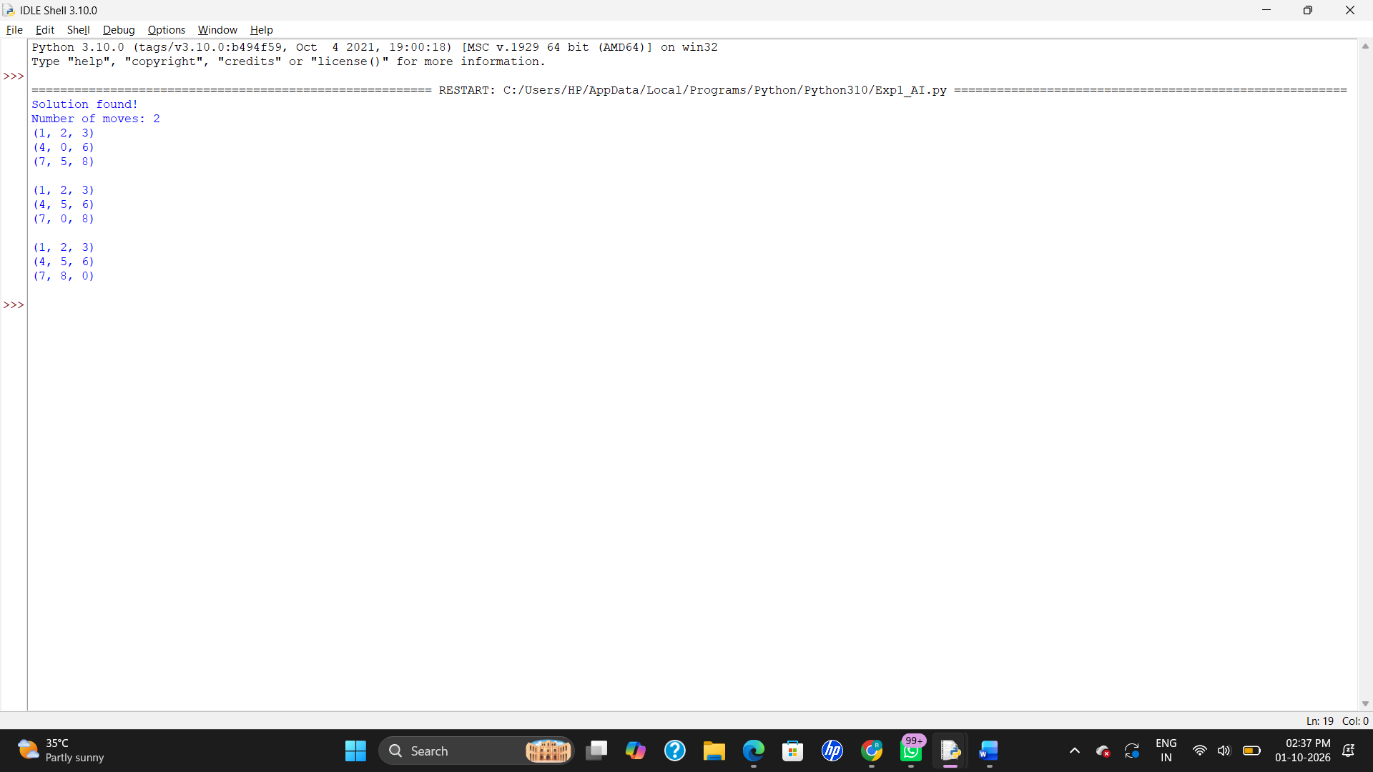
Result:
Thus, the 8-Puzzle Problem was solved successfully using Python and Breadth-First Search (BFS). This follows the structure and BFS approach

EXPERIMENT 2: 8-Queen Problem
AIM
To develop a Python program to solve the 8-Queen Problem by placing 8 queens on an 8×8 chessboard such that no two queens attack each other.
ALGORITHM
- Create an 8×8 chessboard.
- Place a queen in each row.
- Check whether the position is safe.
- A queen should not be in the same column or diagonal as another queen.
- If the position is safe, place the queen.
- Continue placing queens row by row.
- If no safe position is available, backtrack and change the previous queen's position.
- Continue until all 8 queens are placed successfully.
PROGRAM:

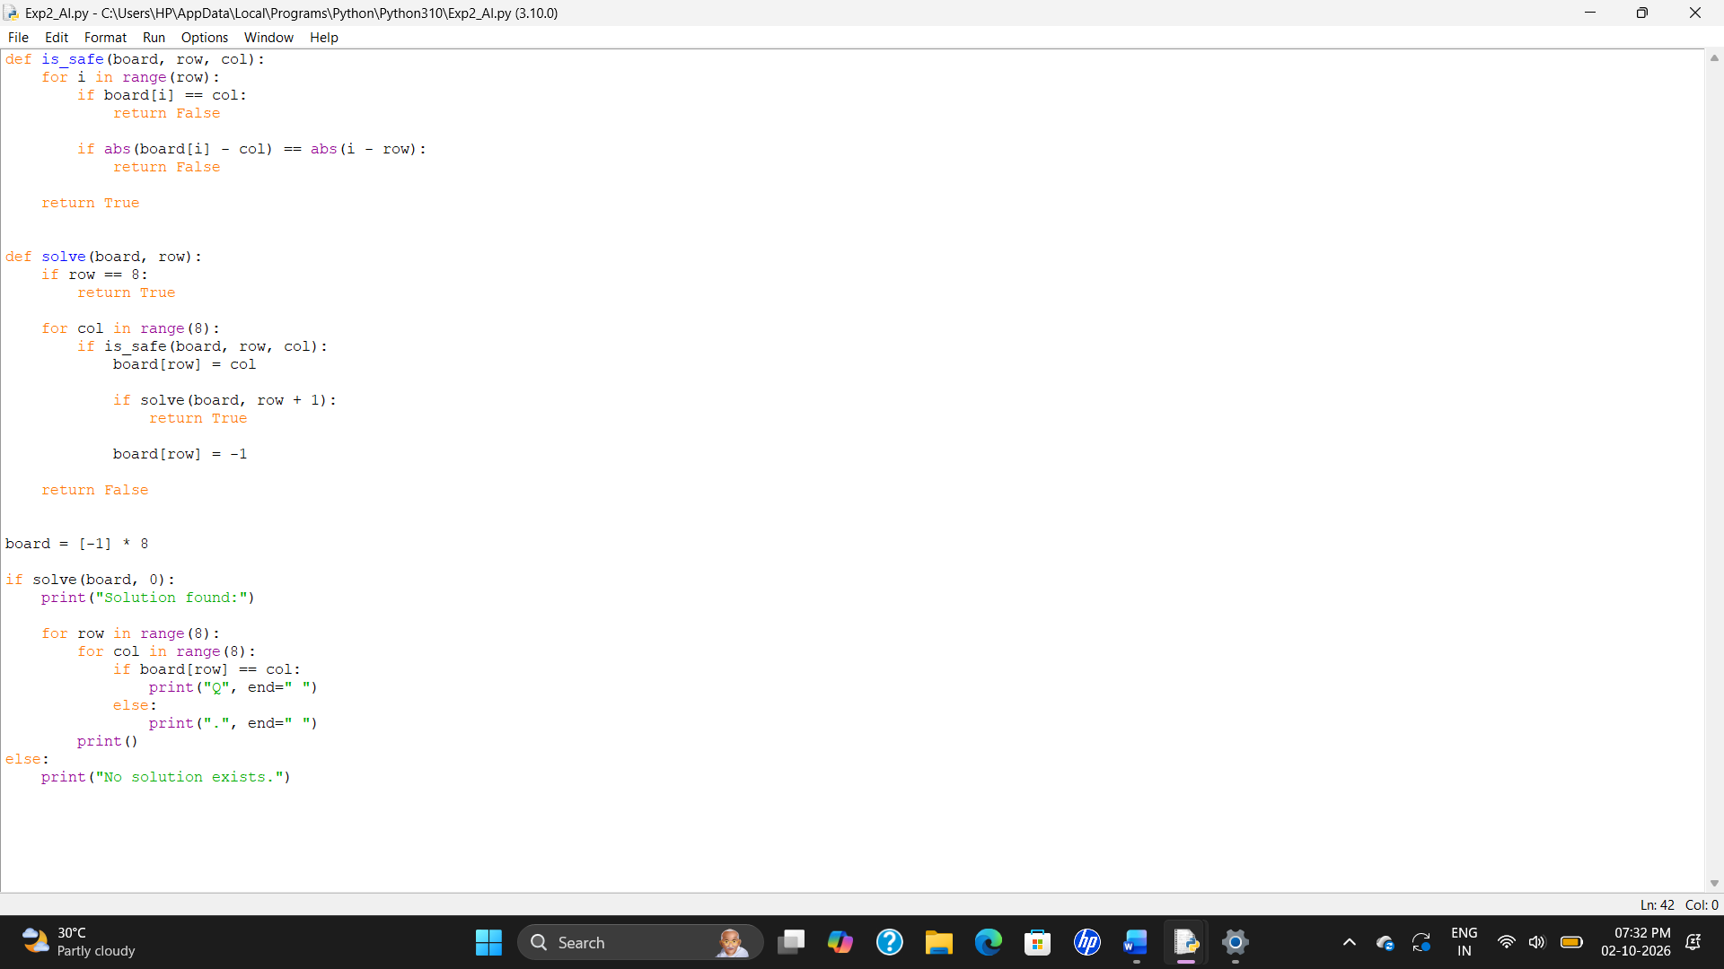
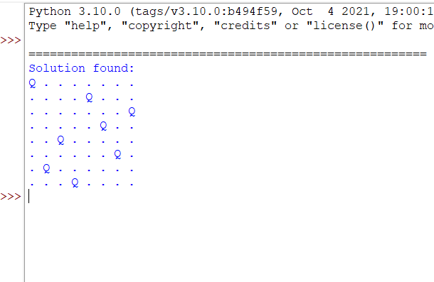
RESULT
Thus, the 8-Queen Problem was solved successfully using Python by placing 8 queens on the chessboard without any two queens attacking each other.

EXPERIMENT 3: Water Jug Problem
AIM
To develop a Python program to solve the Water Jug Problem using a search technique to obtain the required amount of water.
ALGORITHM
- Initialize the capacities of the two jugs.
- Start with both jugs empty.
- Generate possible operations:
  - Fill Jug A.
  - Fill Jug B.
  - Empty Jug A.
  - Empty Jug B.
  - Pour water from Jug A to Jug B.
  - Pour water from Jug B to Jug A.
- Store the visited states to avoid repetition.
- Continue generating states until the target amount is obtained.
- Display the sequence of operations.
PROGRAM
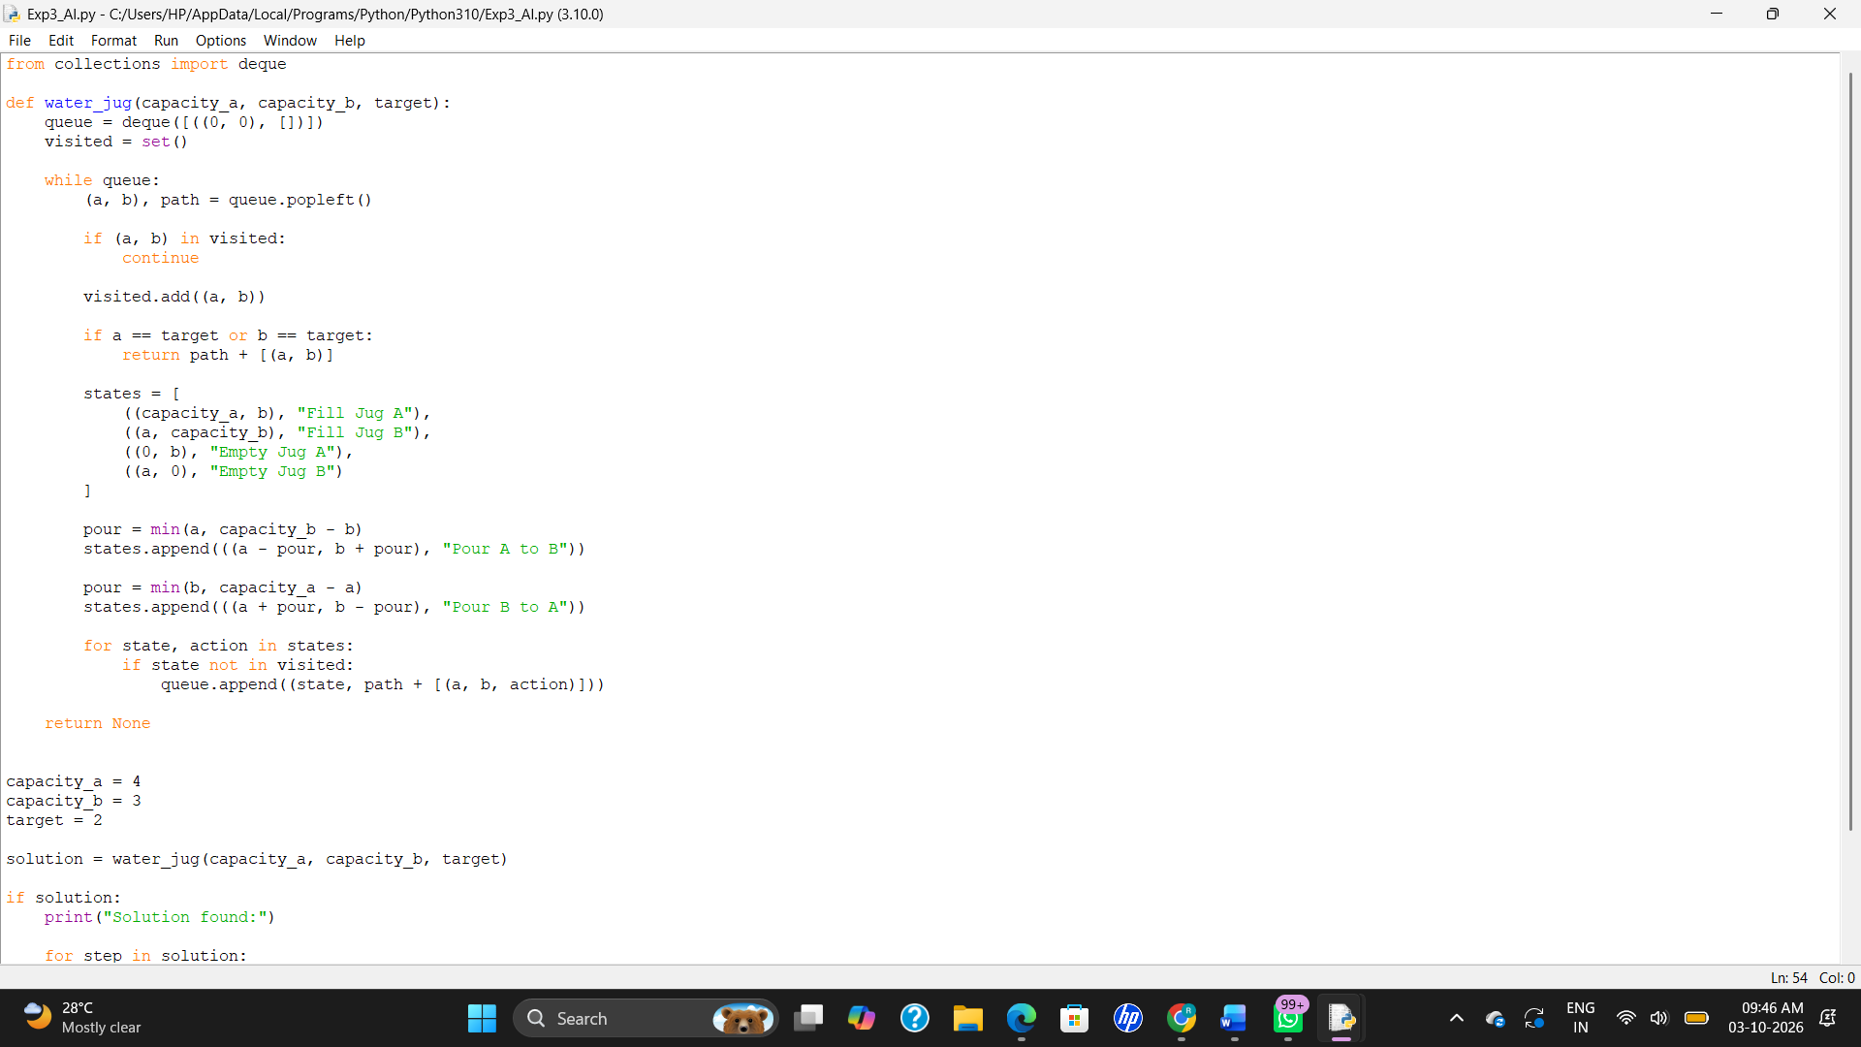

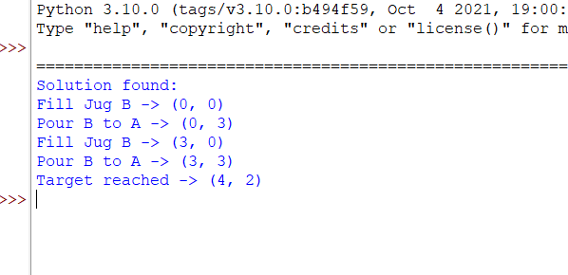
RESULT
Thus, the Water Jug Problem was solved successfully using Python, and the required 2 litres of water was obtained.

EXPERIMENT 4: Crypt-Arithmetic Problem
AIM
To develop a Python program to solve a Crypt-Arithmetic Problem, where each letter represents a unique digit from 0 to 9.
ALGORITHM
- Identify all the unique letters in the given arithmetic problem.
- Assign a different digit to each letter.
- Generate possible digit combinations.
- Check whether the assigned digits satisfy the arithmetic equation.
- Do not allow a leading letter to have the value 0.
- Display the solution when a valid assignment is found.
PROGRAM
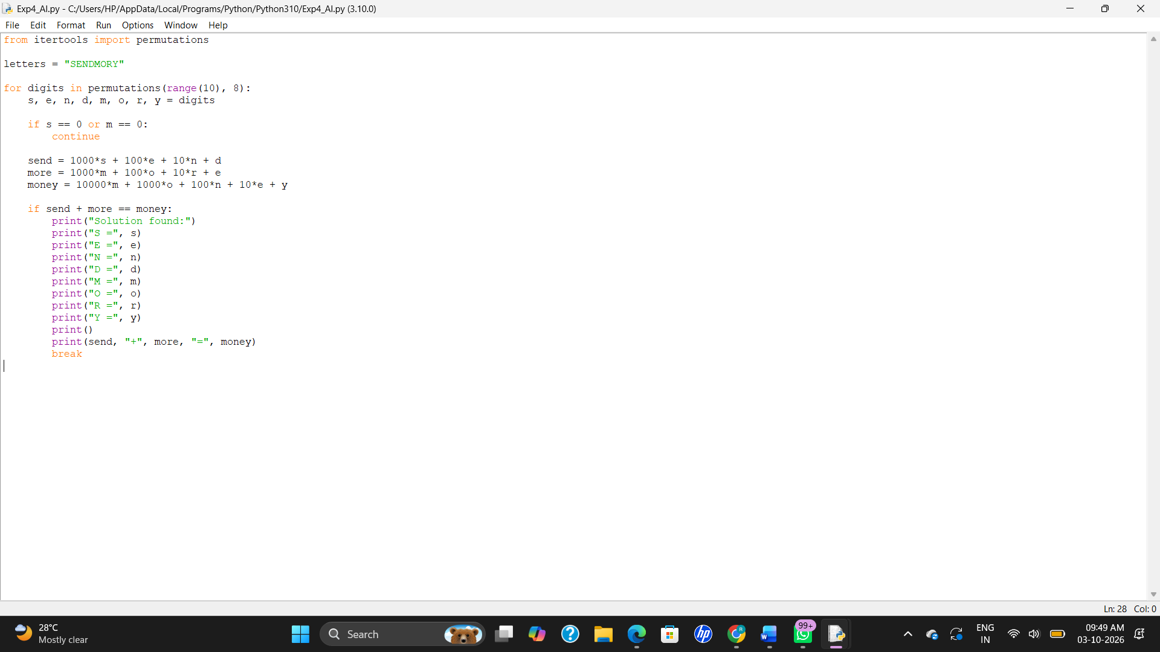

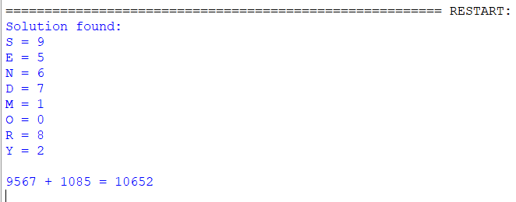

RESULT
Thus, the Crypt-Arithmetic Problem was solved successfully using Python by assigning unique digits to the letters.

EXPERIMENT 5: Missionaries and Cannibals Problem
AIM
To develop a Python program to solve the Missionaries and Cannibals Problem using a search technique.
ALGORITHM
- Represent the state using the number of missionaries and cannibals on each side of the river.
- Start with 3 missionaries and 3 cannibals on the left side.
- Move one or two people using the boat.
- Make sure that cannibals never outnumber missionaries on either side when missionaries are present.
- Store visited states to avoid repetition.
- Continue until all missionaries and cannibals reach the right side.
- Display the solution path.
PROGRAM
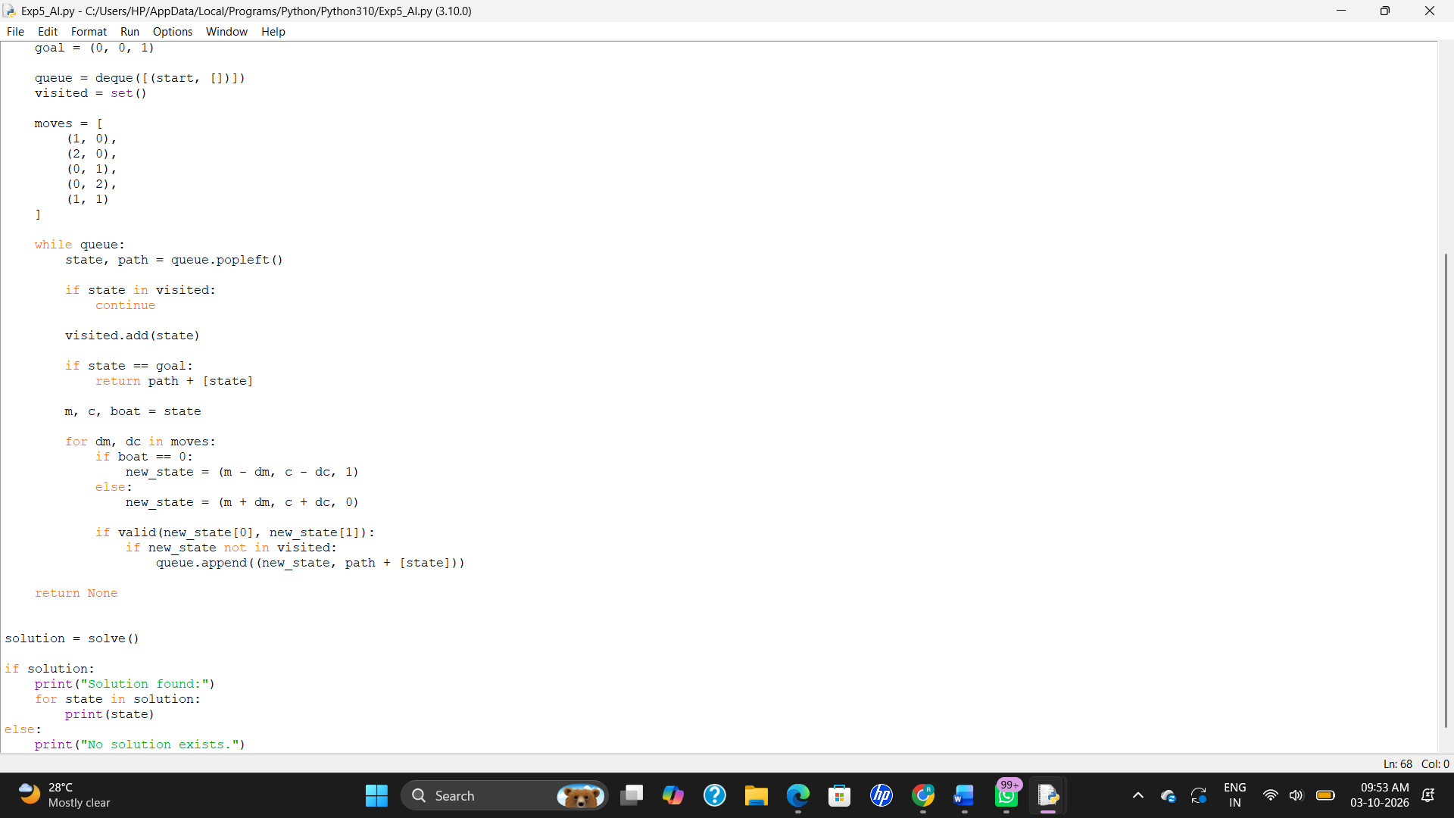
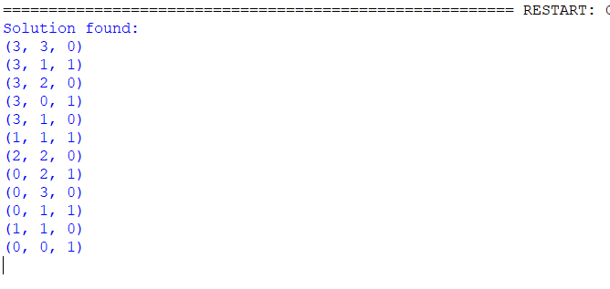

RESULT
Thus, the Missionaries and Cannibals Problem was solved successfully using Python.
EXPERIMENT 6: Vacuum Cleaner Problem
AIM
To develop a Python program to solve the Vacuum Cleaner Problem using a simple rule-based approach.
ALGORITHM
- Represent the environment using two rooms, A and B.
- Represent each room as either Dirty or Clean.
- If the current room is dirty, clean it.
- If the current room is clean, move to the other room.
- Continue until both rooms are clean.
- Display the actions performed by the vacuum cleaner.
PROGRAM
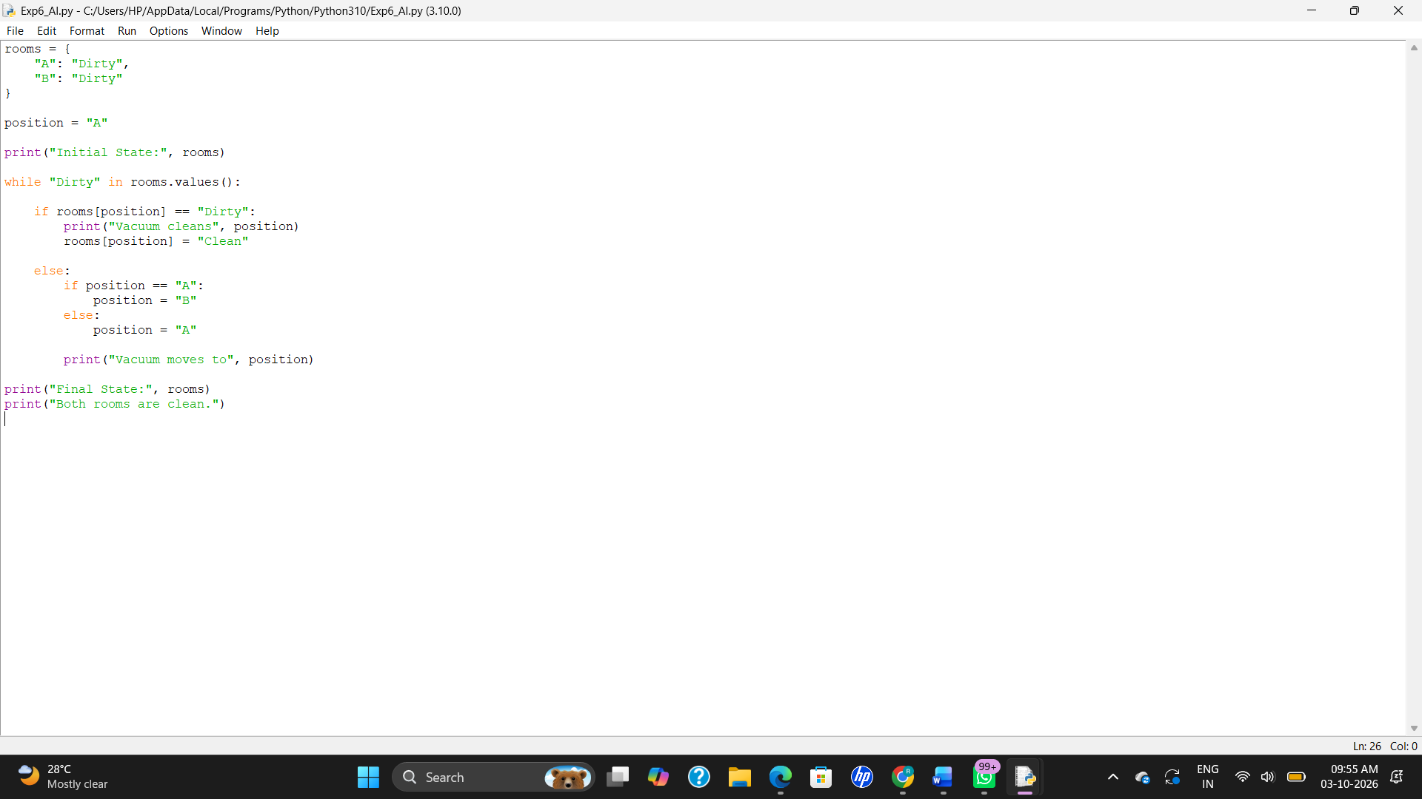

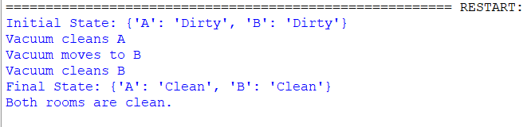

RESULT
Thus, the Vacuum Cleaner Problem was solved successfully using Python.

EXPERIMENT 7: Breadth First Search (BFS)
AIM
To develop a Python program to implement Breadth First Search (BFS) for traversing a graph.
ALGORITHM
- Create a graph using an adjacency list.
- Start from the given starting vertex.
- Create a queue and add the starting vertex.
- Mark the starting vertex as visited.
- Remove a vertex from the queue and display it.
- Add all unvisited adjacent vertices to the queue.
- Repeat until the queue becomes empty.
PROGRAM
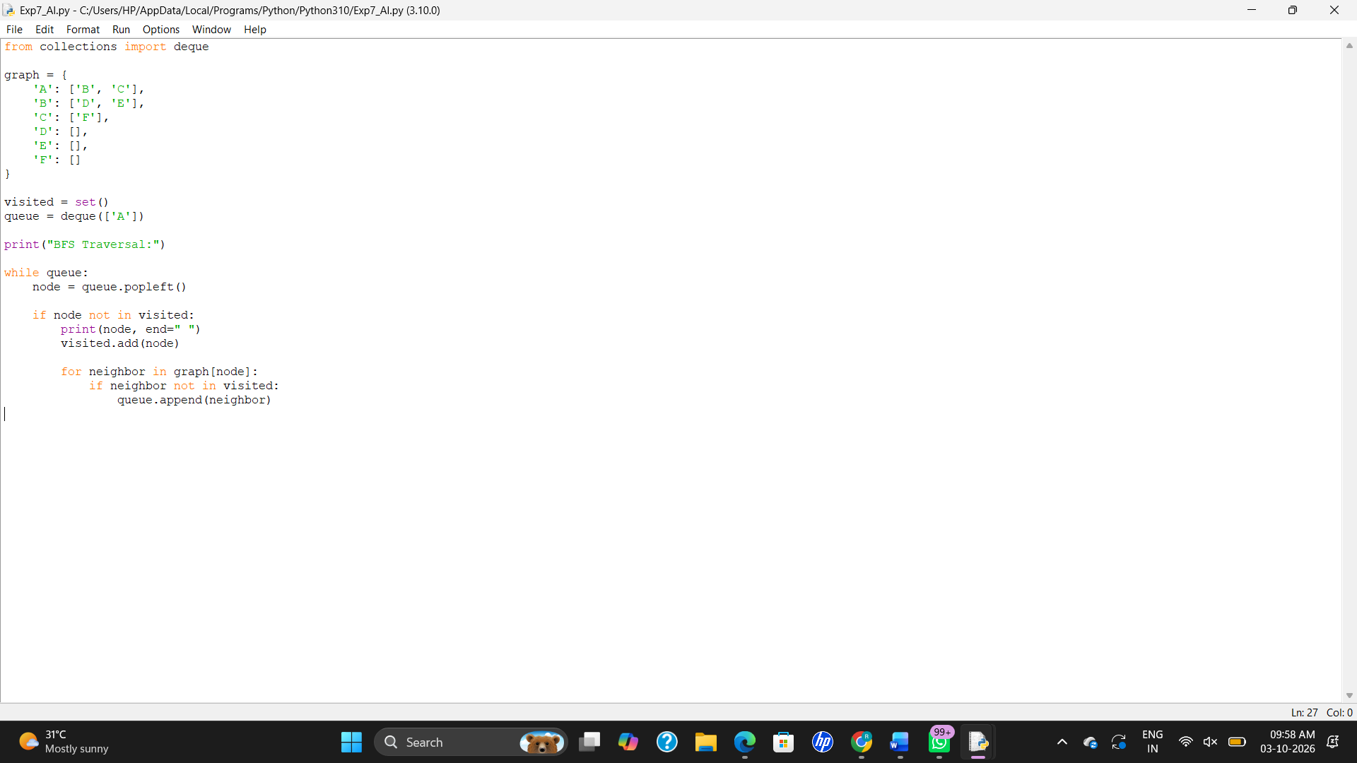

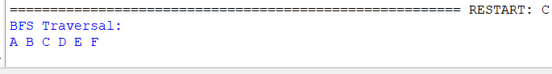
RESULT
Thus, the Breadth First Search (BFS) algorithm was implemented successfully using Python.

EXPERIMENT 8: Depth First Search (DFS)
AIM
To develop a Python program to implement Depth First Search (DFS) for traversing a graph.
ALGORITHM
- Create a graph using an adjacency list.
- Start from the given starting vertex.
- Mark the vertex as visited.
- Display the visited vertex.
- Visit each unvisited adjacent vertex recursively.
- Continue until all reachable vertices are visited.
PROGRAM
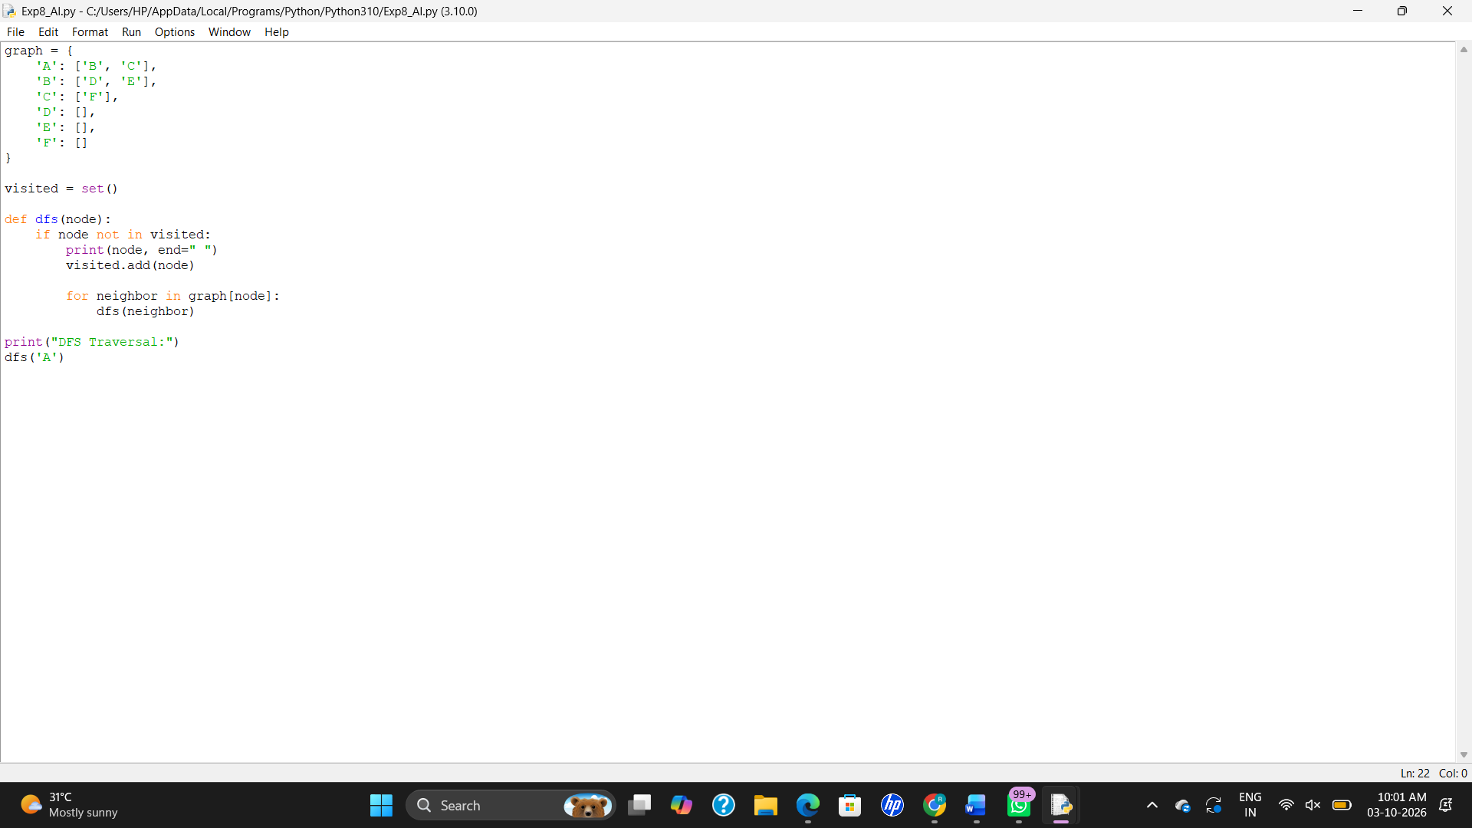

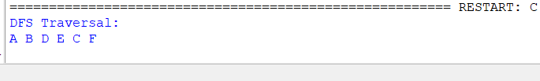
RESULT
Thus, the Depth First Search (DFS) algorithm was implemented successfully using Python.

EXPERIMENT 9: Travelling Salesman Problem
AIM
To develop a Python program to solve the Travelling Salesman Problem (TSP) and find the minimum cost route for visiting all cities exactly once and returning to the starting city.
ALGORITHM
- Represent the distances between cities using a matrix.
- Select the starting city.
- Generate all possible routes through the remaining cities.
- Calculate the total distance for each route.
- Compare all route distances.
- Select the route with the minimum distance.
- Display the shortest route and its distance.
PROGRAM
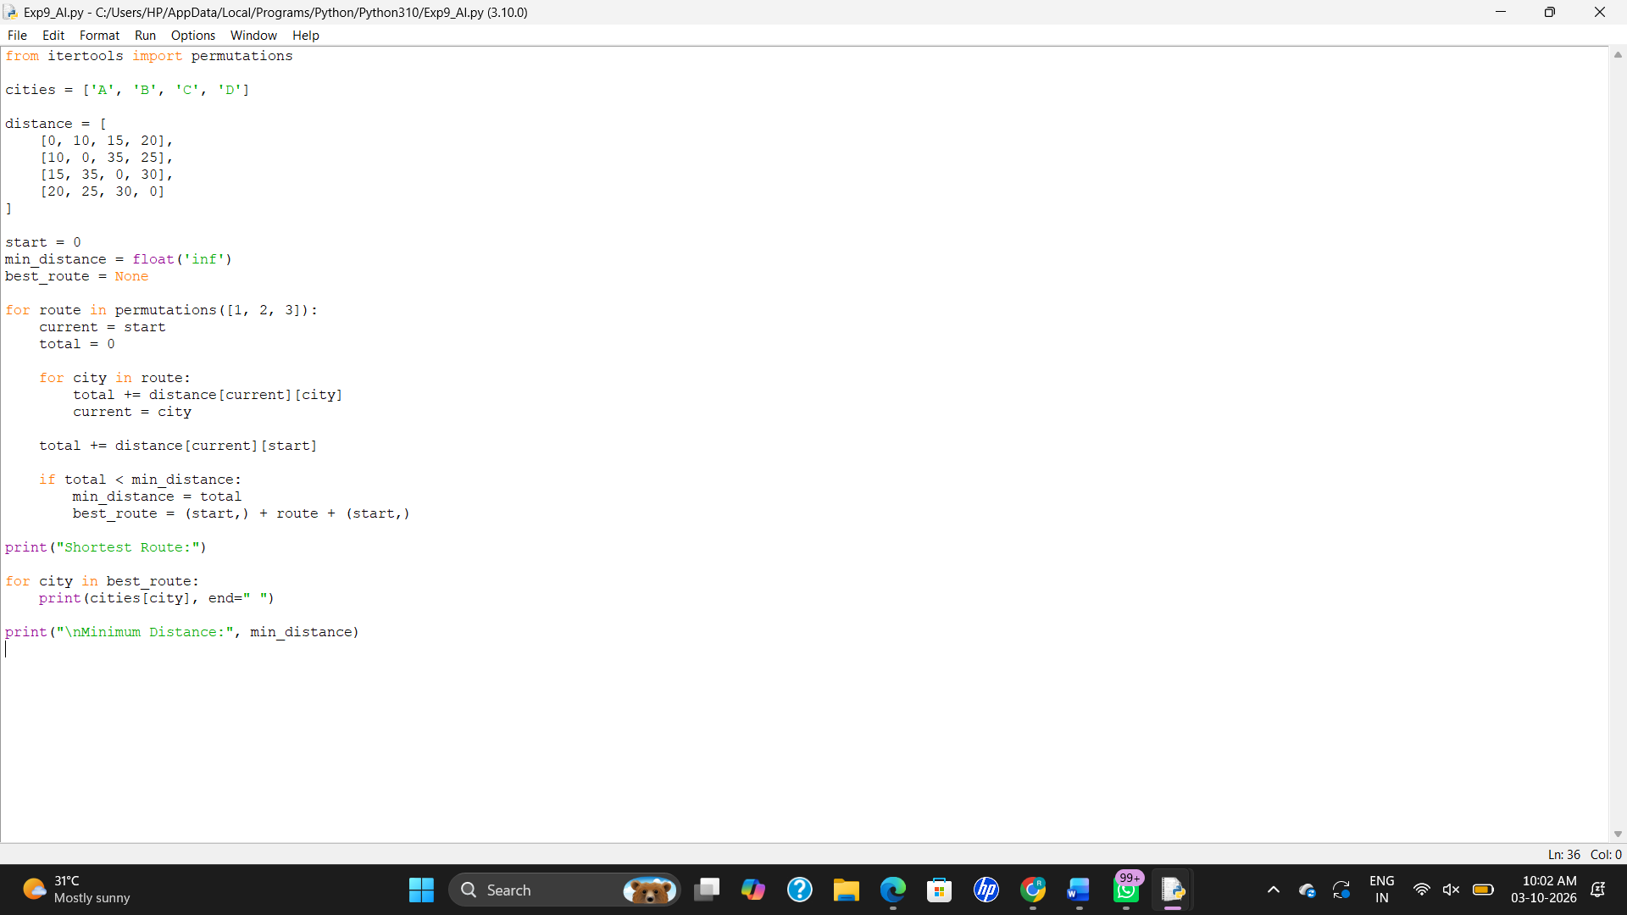
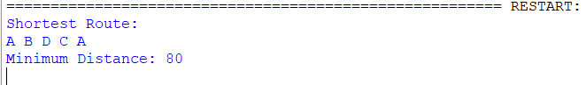
RESULT
Thus, the Travelling Salesman Problem was solved successfully using Python, and the minimum distance route was obtained.

EXPERIMENT 10: A* Algorithm
AIM
To develop a Python program to implement the A* algorithm for finding the shortest path between a start node and a goal node.
ALGORITHM
- Define the graph and heuristic values.
- Set the starting node.
- Calculate the cost function:
f(n) = g(n) + h(n)
- Select the node with the smallest f(n).
- Expand the selected node and calculate the cost of its neighbors.
- Update the path and cost if a better path is found.
- Continue until the goal node is reached.
- Display the shortest path and its cost.
PROGRAM
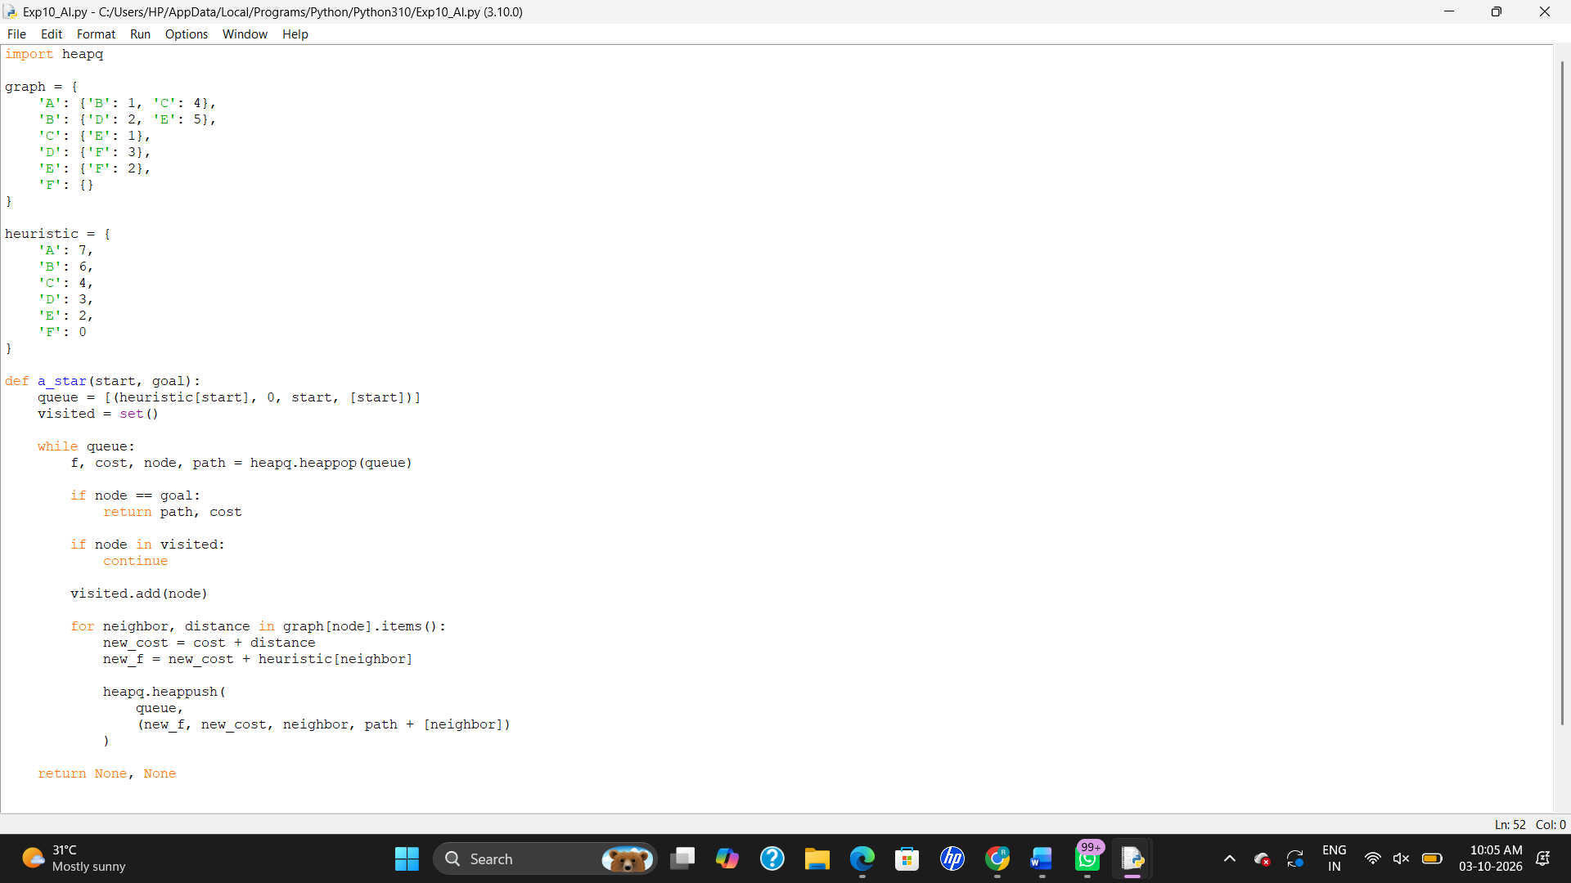

RESULT
Thus, the A* algorithm was implemented successfully using Python to find the shortest path from the start node to the goal node.

